Finding Right place to Rent in Toronto

*Customer Preference Based Predictor*

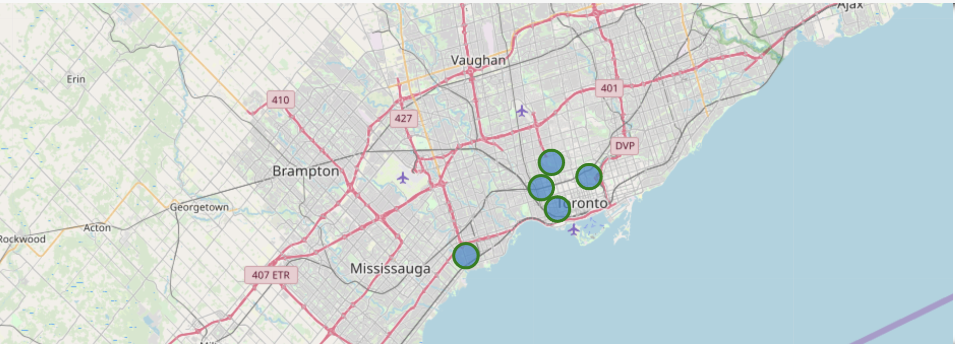

1. Introduction 3

1.1 Business Problem 3

1.2 Target Audience 3

2. Data 3

2.1 Data Collection 3

3. Methodology 3

3.1 Python Libraries 3

3.2 Data Wrangling and Exploratory Analysis 3

3.3 K-Means Clustering 5

4. Data Visualization 6

5. Recommendation and conclusion 7

# Introduction

* 1. Business Problem

An athlete and sports enthusiast student is shifting from his home country to Toronto for higher studies so as result he/she is searching for home to rent near places where sports/fitness areas are located in close proximity. For this reason he has contacted a real estate agent to ease out his work. This project will recommend the areas to the real estate agent where he/she can allocate a home for rent to the student. This project will help the real estate agent in providing better quality of service by allocating proper homes for rent to their customer.

* 1. Target Audience

Sports enthusiastic students looking for home to rent.

# Data

* 1. Data Collection

1. Toronto Poatal Code and Neighborhood data are collected from from the wiki page - <https://en.wikipedia.org/wiki/List_of_postal_codes_of_Canada:_M>
2. 'Geospatial_Coordinates.csv' is imported and merged with the Neighborhood data for further processing
3. Foursquare Data is collected with help of API

# Methodology

* 1. Python Libraries

1. Pandas and Numpy for Data Analysis
2. Wikipedia for extracting data from Wikipedia Page
3. Geopy to extract Geo Coordinates from an address
4. Sklearn to use K-Means Clustering
5. Matplotlib and Folium for Data Visualization
   1. Data Wrangling and Exploratory Analysis
6. Neighborhood data is wrangled by removing unassigned values to Borough and by renaming the columns
7. Geospatial coordinates data is then merged to the Neighborhood data to generate the final dataframe.
8. Toronto Neighborhoods look like below:-

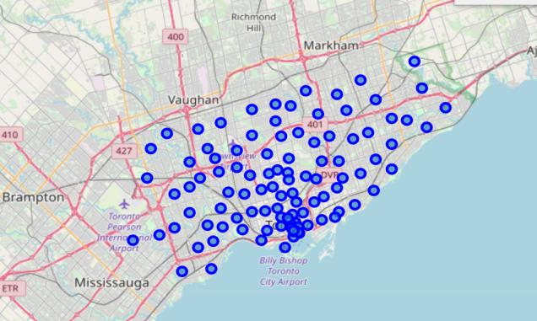

1. A function is written to call the Foursquare API and get top 100 venues in the neighborhoods in Toronto.
2. Each Neighborhood is analyzed by one hot encoding to produce frequency of occurence of different venues in each neighborhood
3. The data is grouped by Neighborhood and filtered with only below venue categories:
   1. Park
   2. Gym
   3. Gym / Fitness Center
   4. Sporting Goods Shop
   5. Yoga Studio
   6. Playground
   7. Trail
   8. Baseball Field
   9. Athletics & Sports
   10. Pool
   11. Basketball Stadium
   12. Hockey Arena
   13. Baseball Stadium
   14. Skate Park
   15. Soccer Field
   16. Stadium

The data looks like below

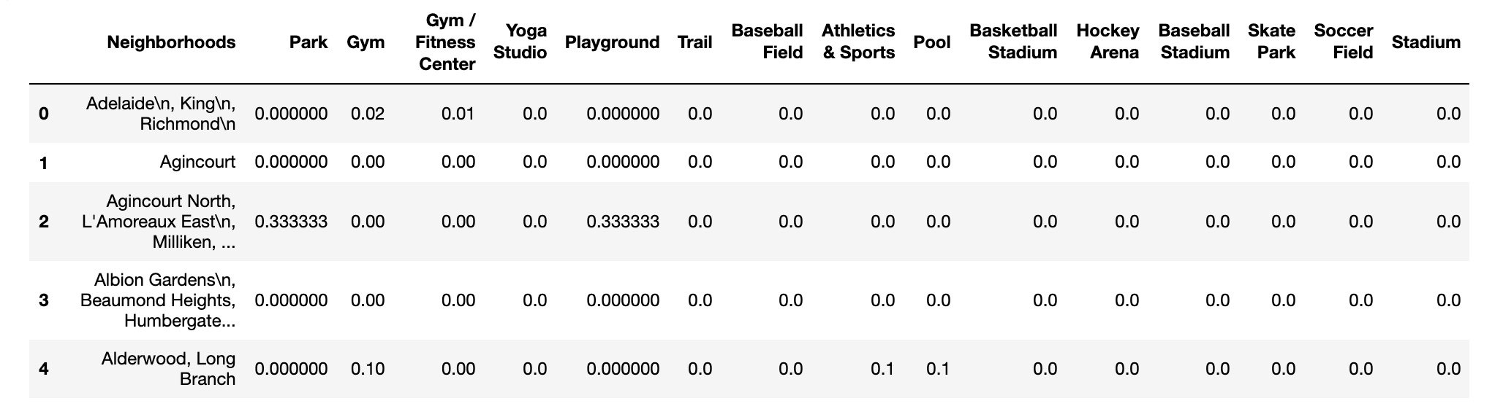

* 1. K-Means Clustering

1. A K-Means clustering with 3 clusters have been performed
2. Cluster labels are added to the dataframe

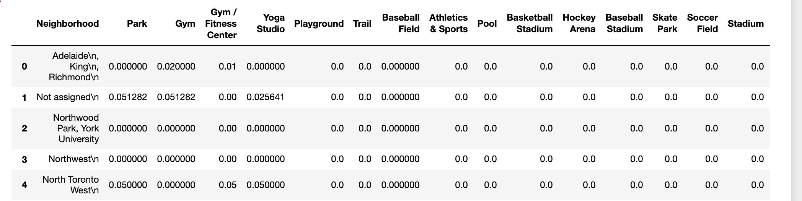

Below are the sum of occurances of each sporting venue in each cluster and statistics of the clusters:-

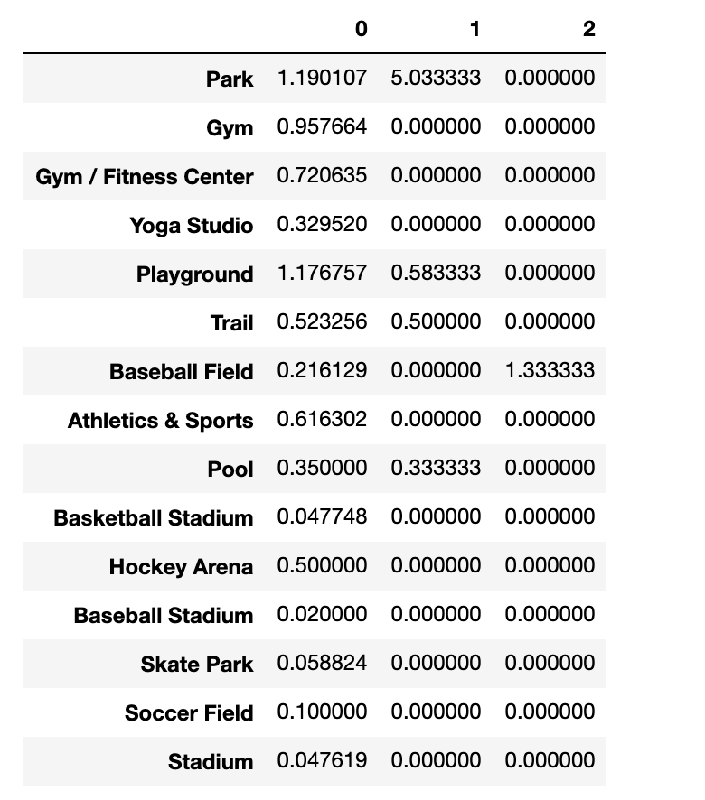

# Data Visualization

1. The below box plot chart shows that wide variation and frequency of Sporting Venues are present in Cluster 0.

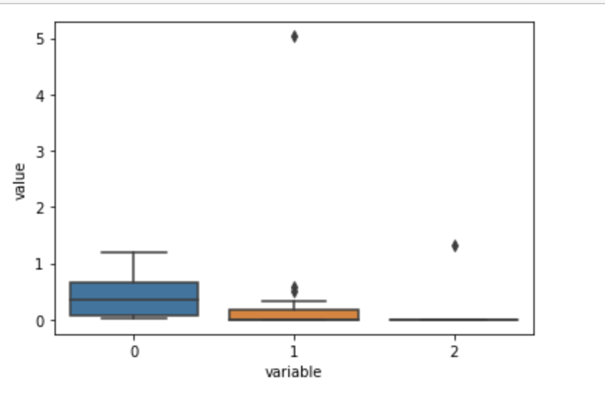

1. The Neighborhood clusters in the map of Toronto has been plotted with help of matplotlib and folium.

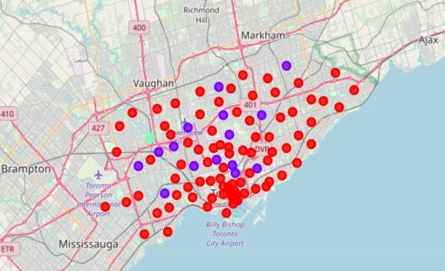

* 1. Red dots belong to Cluster 0,
  2. Purple dots belong to Cluster 1,
  3. Green dots belong to Cluster 2

# Recommendation and conclusion

As per our initial assumption, the real estate agent would like to recommend an area where there are Sporting related venues in close proximity. As per our analysis, Cluster 0 could be recommended. However, there are several neighborhoods in cluster 0. In order to recommend top 5 neighborhoods, below steps are performed.

* 1. The dataframe was sorted based on maximum types and maximum count of venues
  2. The top 5 Neighborhoods are recommended to open the store
     1. Business Reply Mail Processing Centre 969 Eastern (Cluster 0)
     2. Rosedale (Cluster 1)
     3. Moore Park, Summerhill East (Cluster 1)
     4. Thorncliffe Park (Cluster 0)
     5. Queen's Park (Cluster 0)

The top 5 recommended neighborhoods look like this:

